

PROGRAMMING LAB SUBMISSION
Fundamentals of Computer Programming (C++)
Program: BS Computer Science (BSCS) | Section: A
Student Name: | Muhammad Waleed Hassan

Task 1: ASCII Numbers
2. Code Screenshot
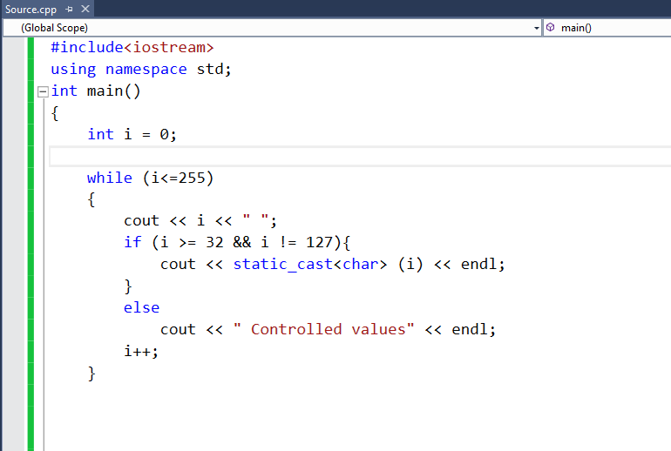
3. Output Screenshot
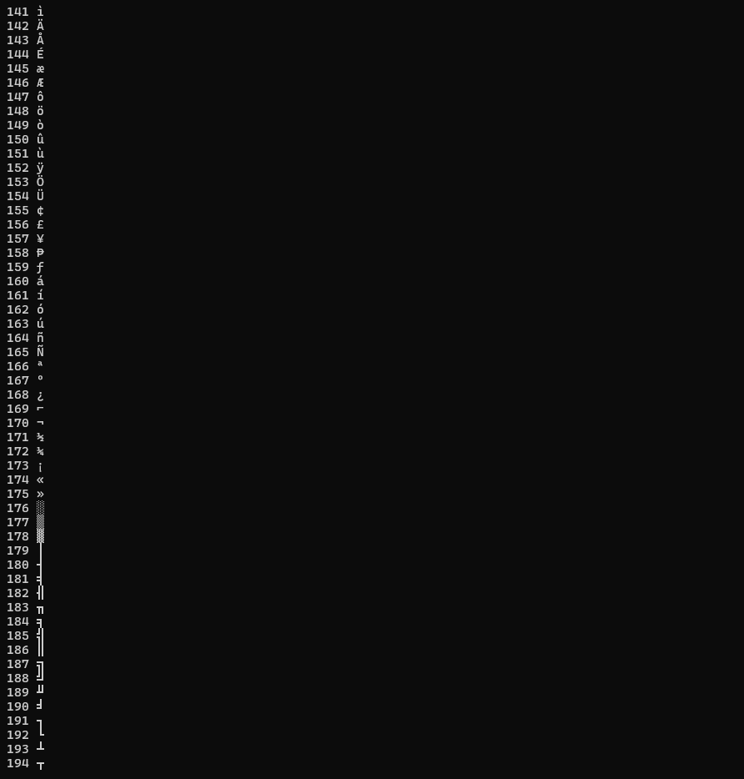

Task 2: 1 to 5 Factorials

2. Code Screenshot
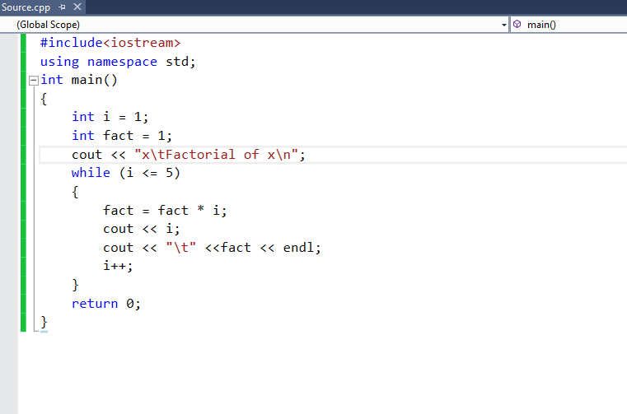

3. Output Screenshot
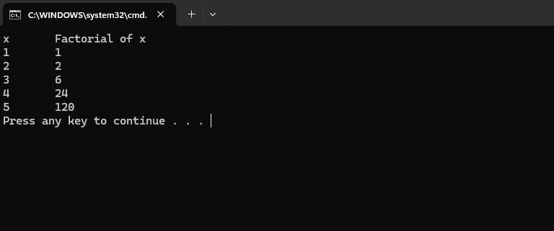

Task 3: Number Guessing Game
2. Code Screenshot
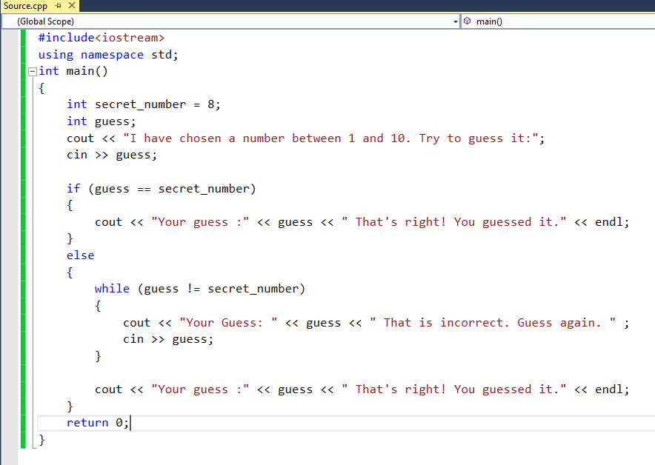
3. Output Screenshot
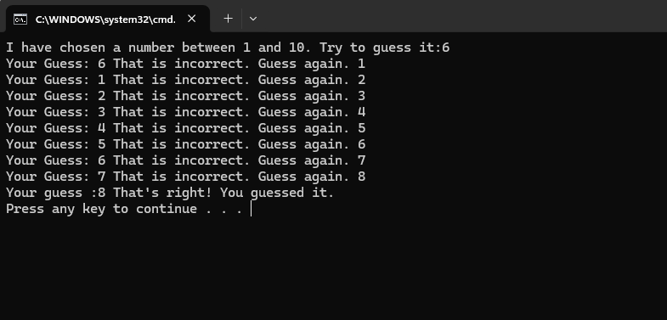
Task 4: Find GCD
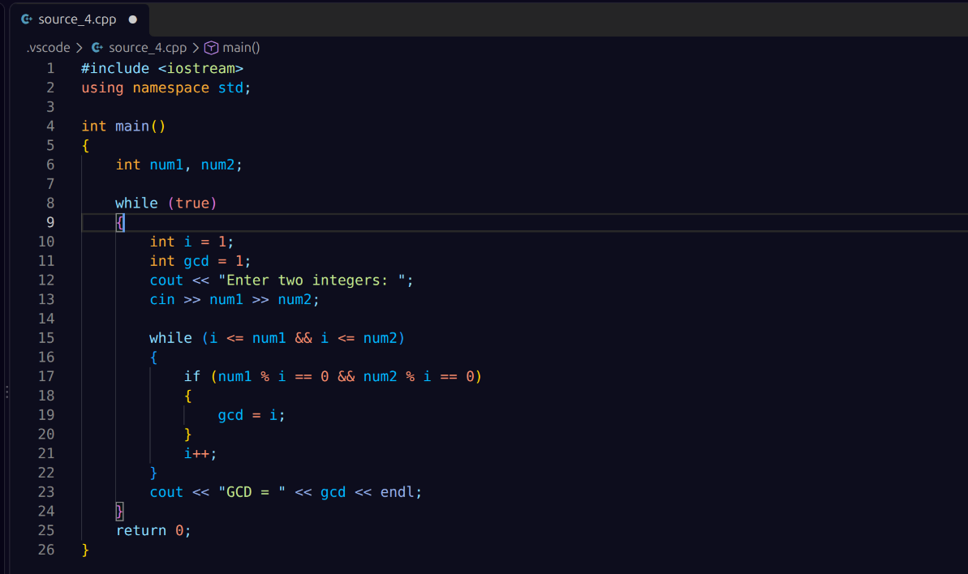
2. Code Screenshot

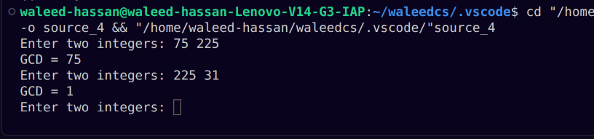
3. Output Screenshot

Task 5: Prime Numbers btw 2 and 10000
2. Code Screenshot
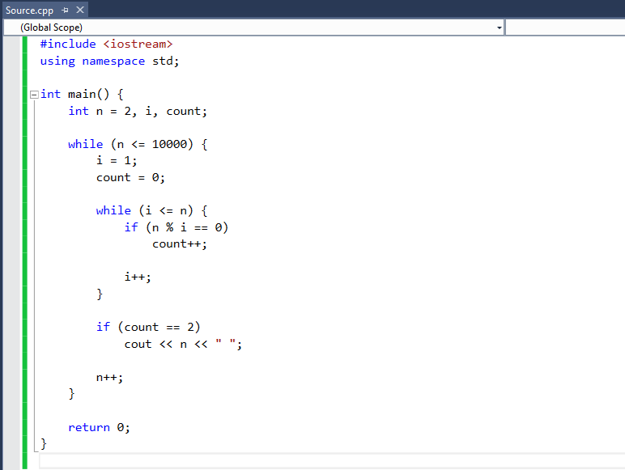
3. Output Screen
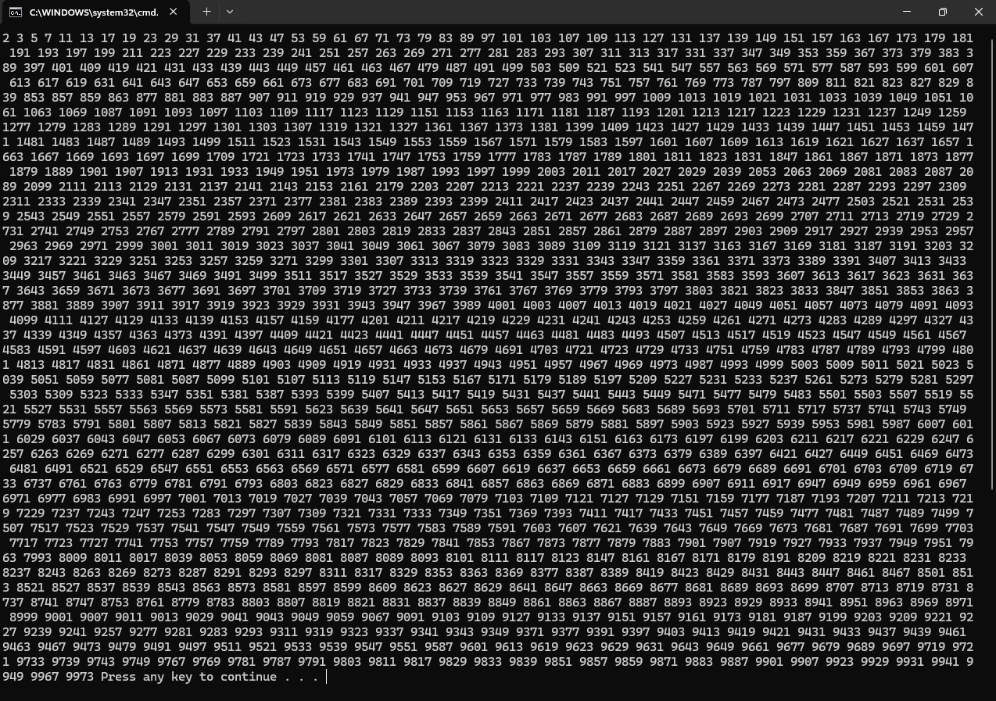
Task 6: Calendar
2. Code Screenshot

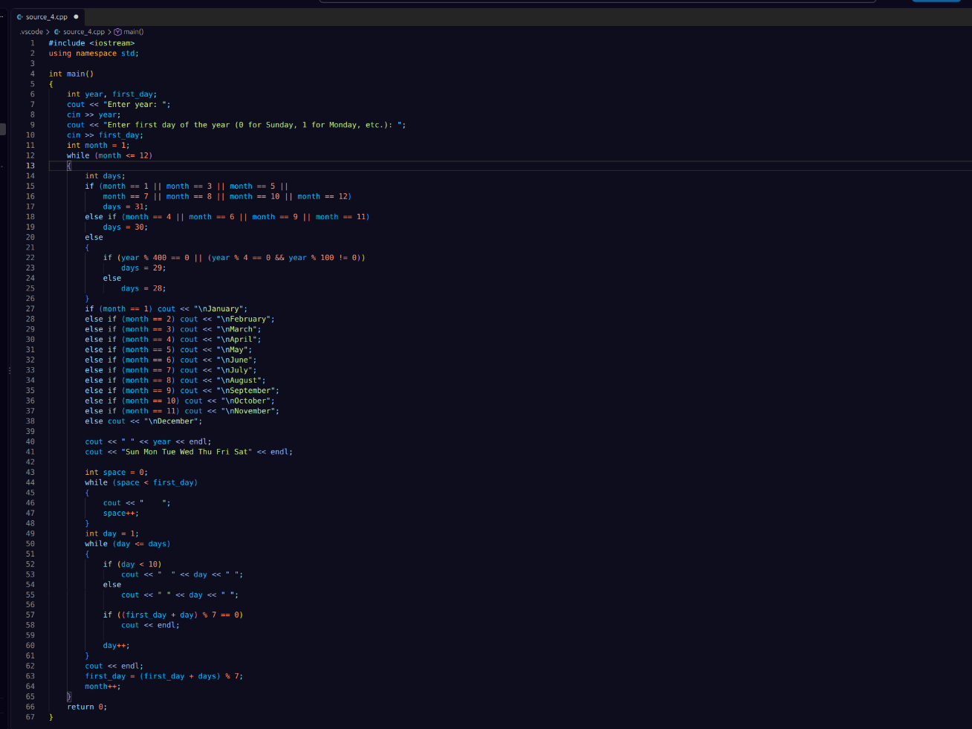
3. Output Screenshot
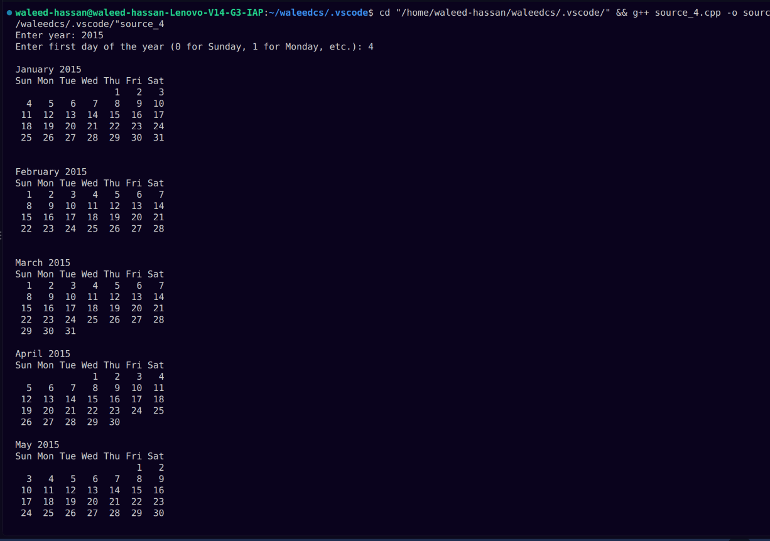
Task 7: Number Pyramid
2. Code Screenshot
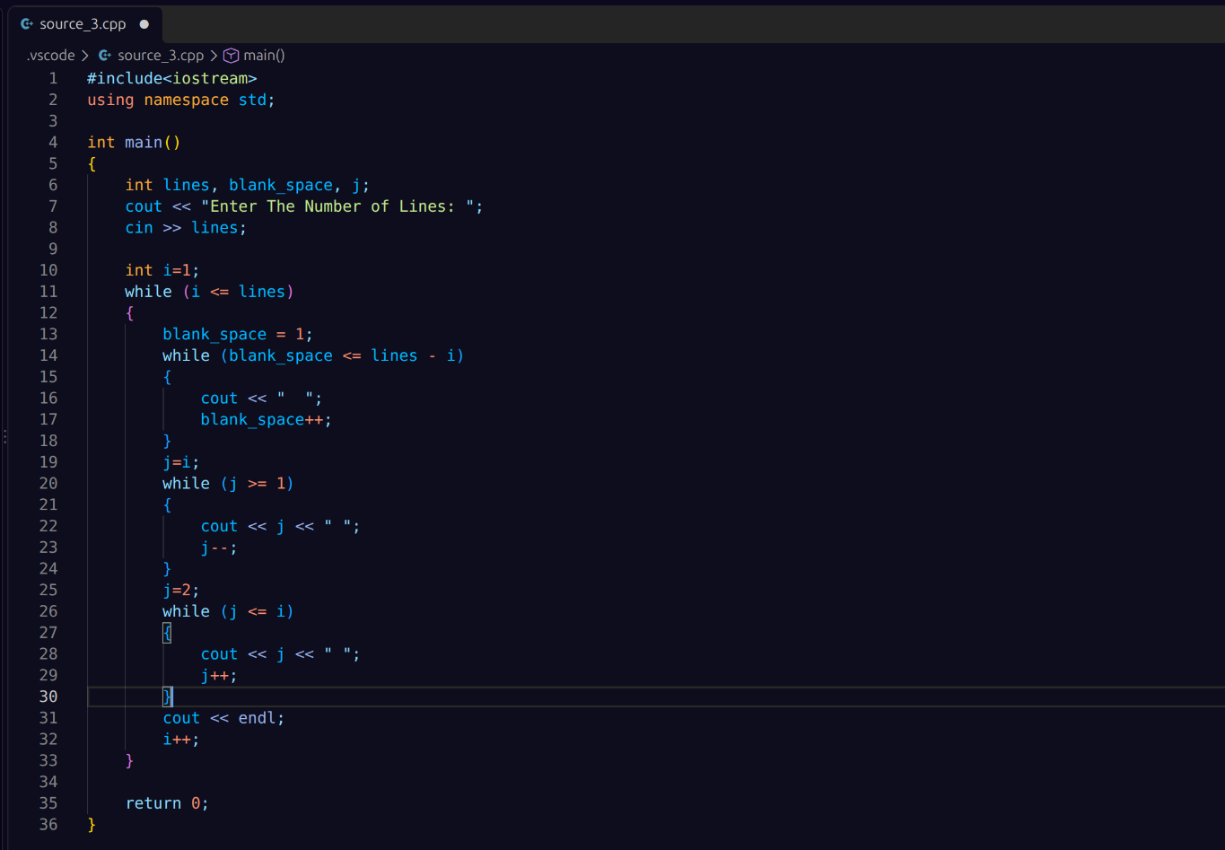
3. Output Screenshot
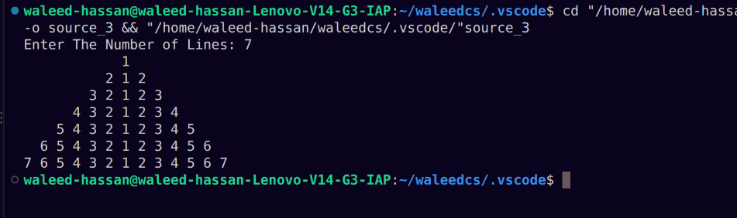

Task 8: Annual Interest Rate
2. Code Screenshot
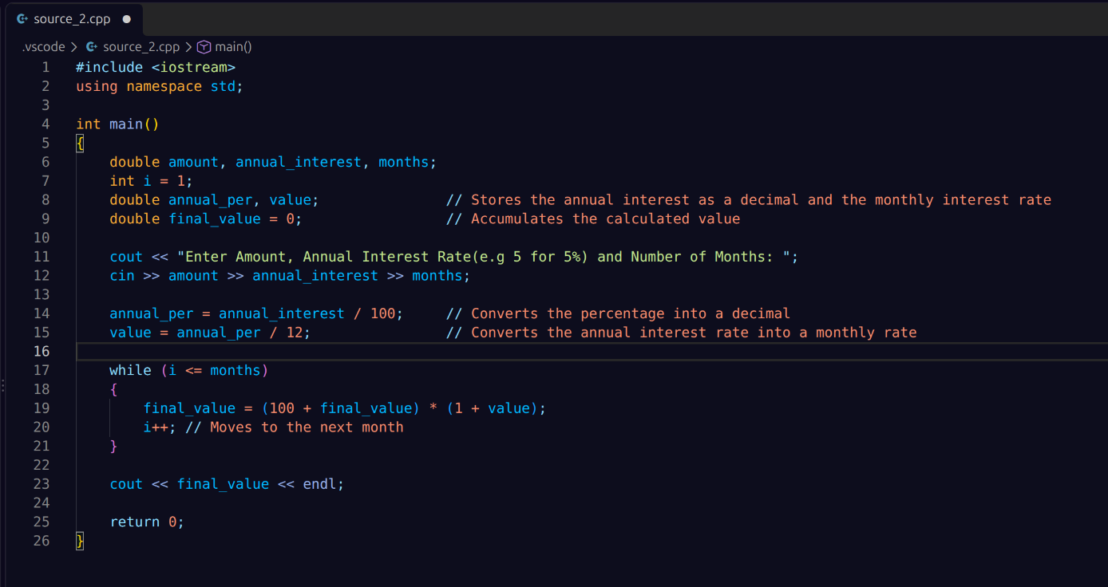
3. Output Screenshot
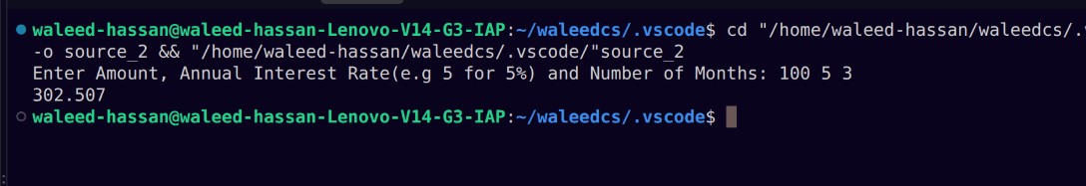

Task 9: Monte Carlo Simulation
2. Code Screenshot
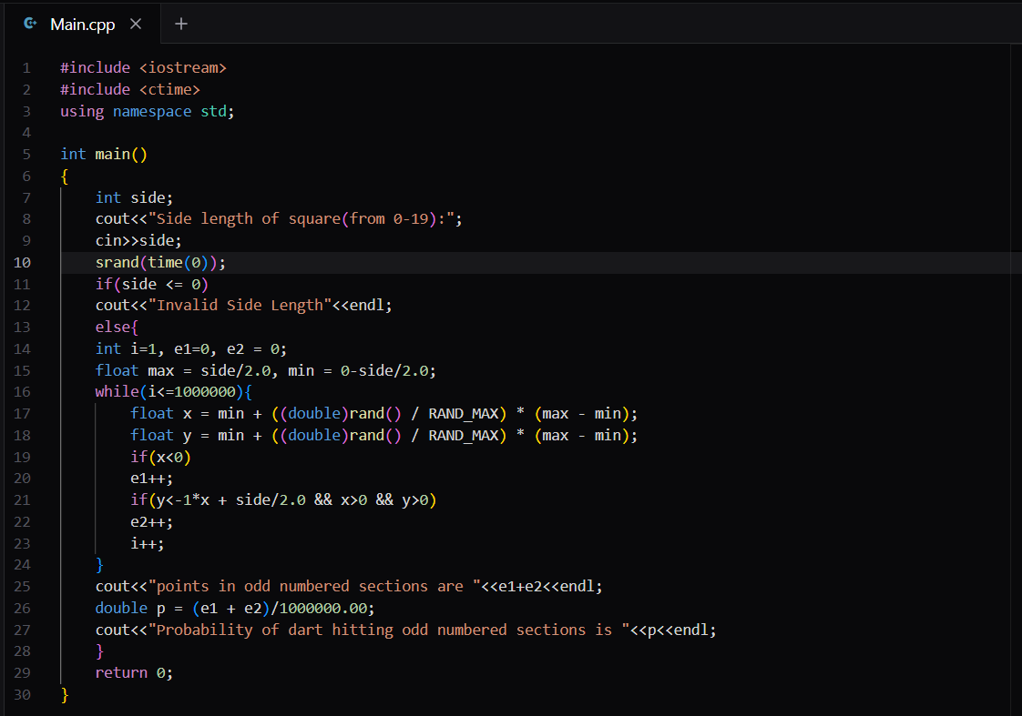
3. Output Screenshot

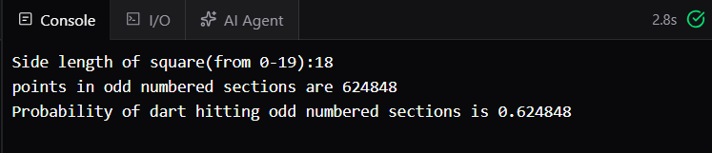

Task 10: Number Multiplication and Their SUM
2. Code Screenshot
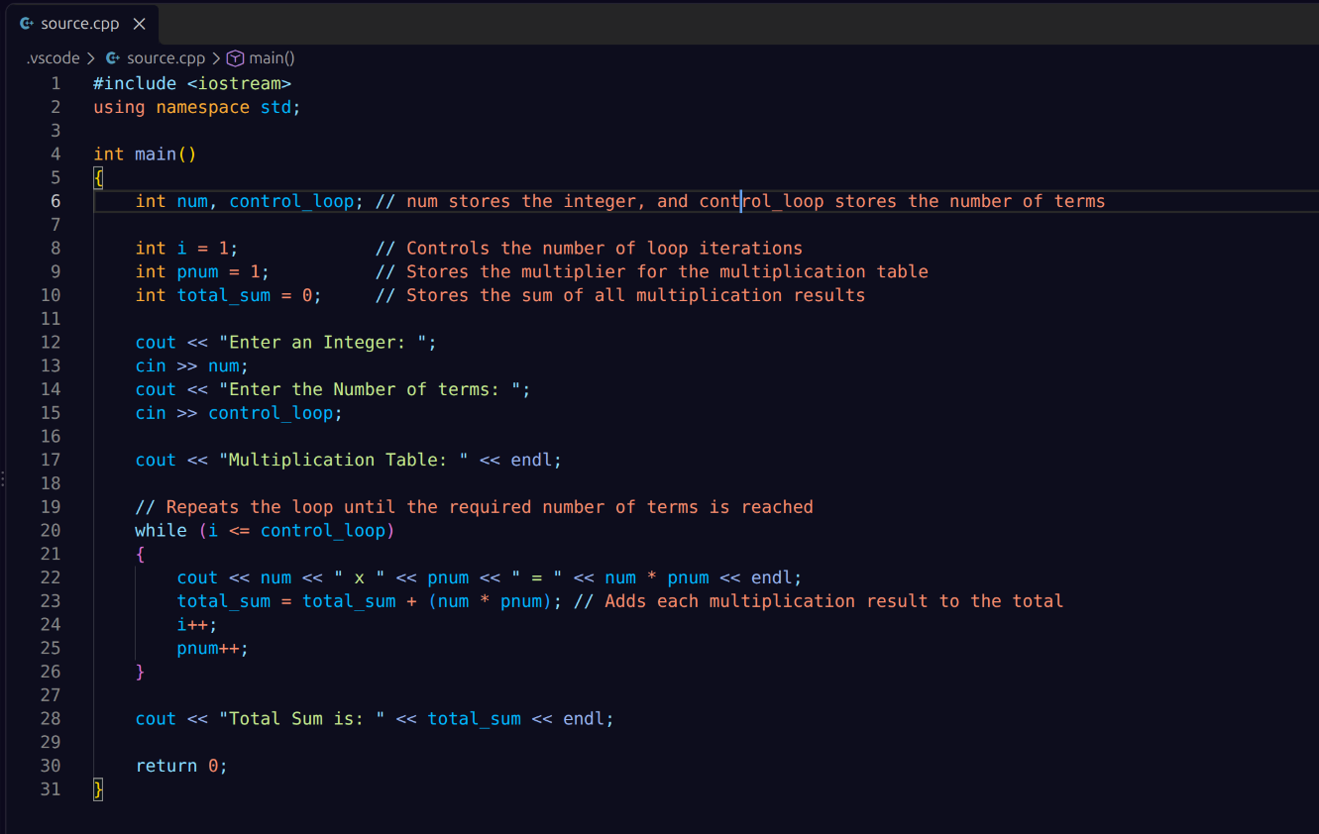
3. Output Screenshot
